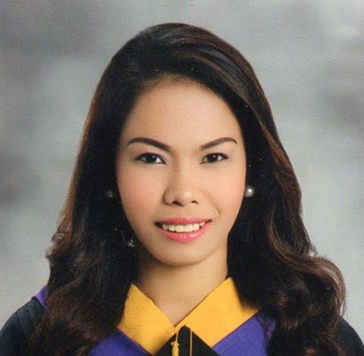
CURRICULUM VITAE

MA.JEREMIE MIÑOZA
Burgos Pulangbato Cebu City,Philippines 6000
Mobile No. 09096678913/ 09232270070
jern_76@yahoo.com.ph

Job Objectives
A Recent College Graduate who has less experience but is willing to learn and be train to be able to enhance my skills and capabilities and also I have a lot of curiosities about technology, And also to become part of the success in your company.
Special Skills

- Has knowledge In VB language
- Database
- HTML, SQL, PHP
- Photoshop
- Computer Formatting
- Web Developing
- Microsoft Application

EDUCATIONAL ATTAINMENT

A. Tertiary
- Bachelor of Science in Information System
- University of Cebu
- Cebu City, Philippines
- Fresh Graduate ( 2013-2014 )

B. Secondary
- Pit-os National High School
- Pit-os Cebu City, Philippines
- Year 2005 – 2009

C. Primary
- Pulangbato Elementary School
- Pulangbato Cebu City, Philippines
- Year 1999 - 2005

WORKING EXPERIENCE

SPES
- Special program for employment of students
- Cebu City Hall(Business Permit Section)
- 2009 (April - May)
- 2010 (April - May)

Hotel Elizabeth Cebu

- IT Assistant
- Reformatting of Computer
- WIFI Troubleshooting
- Computer Assembling and Disassembling
- Computer Cleaning
- Camputhaw Cebu City
- 2013(June - September )

Certification

- Certified PSITS member of University of Cebu Banilad Campus in the year 2009 till 2014
- Certificate of participation in 1st and 2nd UC-ICT congress held on Cebu Coliseum and SM Cebu Trade Hall.
- Certificate for Completing the National Service Training Program
- Certificate of Participation for the Professional and Work Ethics Seminar last 19th of September 2011.
- Certificate of Participation for the Job Hunting Seminar last 19th of September 2011.
- Certificate of participation for actively participating during the 2nd Cebu City Youth Congress last 20th day of December year 2013.
- Certificate of Appreciation for offering voluntary Service during the Unified College Days 2013

PERSONAL DATA

Age : 21 years old
Birth Date : December 02, 1992
Birth Place : Pulangbato Cebu City
Height : 5’5”
Weight : 53 kgs
Civil Status : Single
Religion : Catholic
Gender : Female

CHARACTER REFERENCES

- Mrs. Moma dela Torre-Ortega
College of Computer Studies-Chairperson
College Instructor
University of Cebu-Banilad
Mobile No.: 09273869120

- Ms. Noreen Barrita
Accenture
Admin/Reporting
Mobile No.: 09177038811

- Mr. Van Philip Dolino
IT Assistance
Hotel Elizabeth Cebu
Mobile No.: 09322394585

  - Mrs. Annabel Reambonanza
HR Manager
Hotel Elizabeth Cebu
Mobile No.:09228998014

